Holt Community Primary School

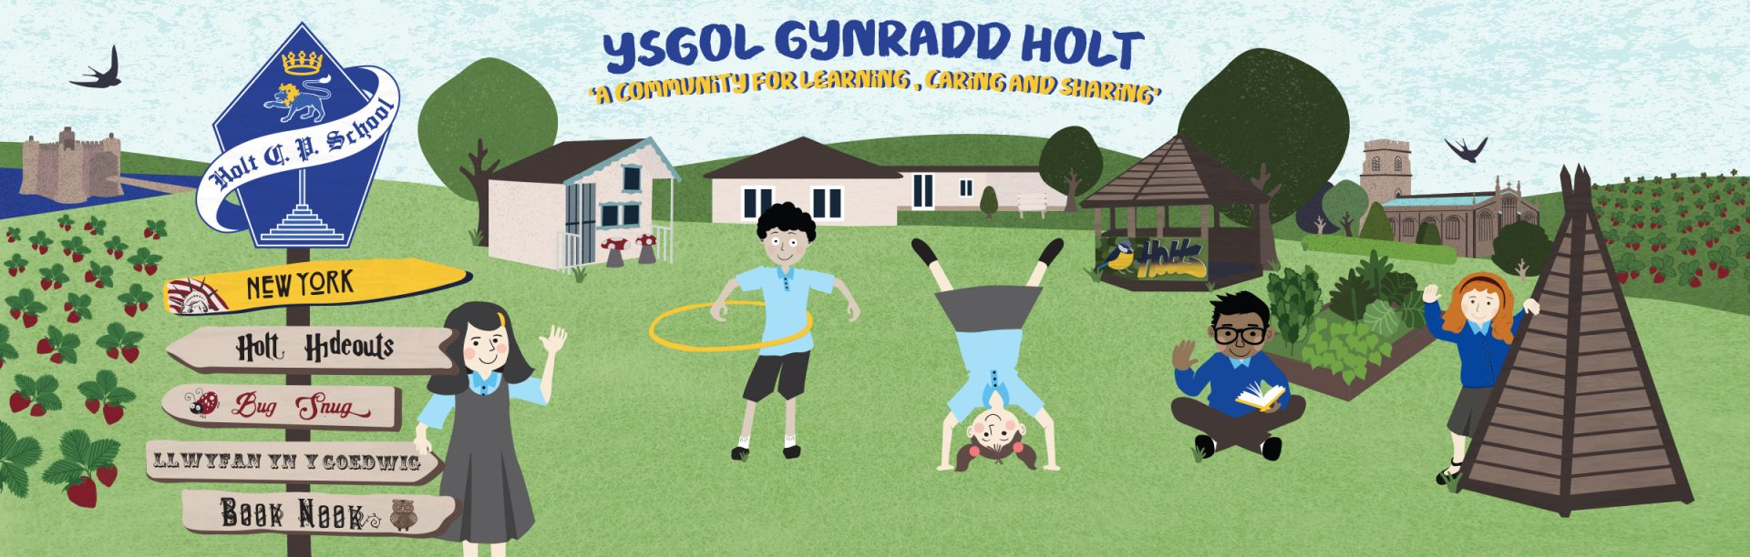

Pupil Information Booklet

Hello and welcome back!

It will be so lovely to see you all back at school in September, but things will continue to look and be a little different here for a while. We have put this pack together to explain to you some of our rules because of Coronavirus. This means we will have to work extra hard to keep ourselves and everyone else healthy. If you follow these rules, it will help to make sure that we do not spread the Coronavirus at school. We know things will be tough, but it is really important that when we see you back at Holt Community Primary School we use this time to follow certain rules for a while longer.

Mrs Sturt

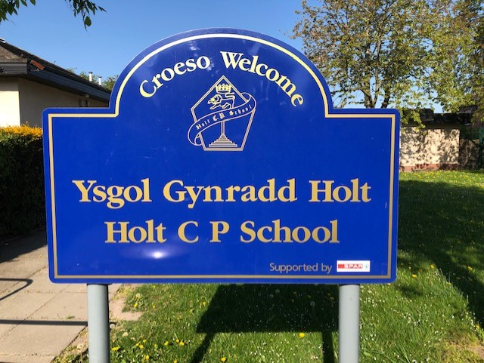

ARRIVING AT SCHOOL

- Enter the school through the rear gate via the Car Park.
- Access your classroom via your patio doors.
- Wash your hands at your allocated sink.
- Go straight to your classroom and sit at your allocated desk.
- Stay in your classroom.
- Stay at least 2m away from staff.
- If someone is in the cloakroom, allow them space, maybe wait until they are out.

BREAK TIME

- Wash your hands before eating your snack in your designated sink.
- Exit class through doors leading directly outside.
- At playtimes, stay within your allocated zone on the school field/yard.
- Stay 2m away from staff on duty. No invasion games, no games involving shared items.
- Only one in the toilet at a time. An adult will be supervising.
- Wash your hands when you return from break.
- Wet play times: stay in class and sit at your table. iPads can be used but must be wiped down afterwards.

LUNCHTIME
- Wash your hands before eating.
- Sit at your table in the classroom to eat, either your packed lunch or school dinner.
- Your table will be wiped clean before and after eating.
- Dispose of rubbish in your lunchbox or the bin provided.
- Wash your hands after eating.
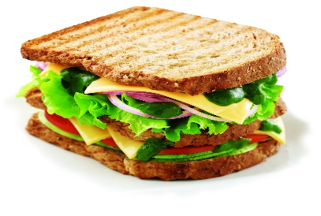
- Do not share food.
This Photo by Unknown Author is licensed under CC BY
- Use your own water bottles for drinking.

TOILETS
- Use the toilet allocated to your class only.
- Toilet breaks will be timetabled.
- Only one child in the toilets at any one time.
- Wash your hands in the allocated sink.
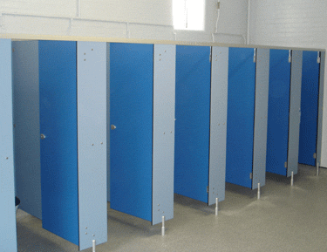
- You should always have an adult with you whilst visiting the toilet/sink area supervising hygiene and numbers in the toilets.

WASHING HANDS
- Wash your hands with soap and hot water for at least 20 seconds.
- Dry your hands thoroughly.
- Wash your hands regularly through the day – arriving at school, before and after eating, after play time.
- Do not share the hand drier.
- Allow for distancing at sinks, this may mean waiting your turn.

ILLNESS

- If you are feeling unwell let the class teacher know as soon as possible.
- Remember to cough/sneeze into your arm
- Wash your hands after coughing/sneezing.

CONCERNS OR PROBLEMS

- If you have any concerns or are worried then speak to your teacher or teaching assistant.

THE CLASS

- Use the equipment in your trays only.
- Please do not share your equipment with anyone else.
- Please do not use any other equipment in the class without getting permission.
- Stay at your table to do your work.
- Keep 2m away from the staff.
- If you need to leave the room to use the toilet you will be taken by an adult.
- Bring your own drink to have at your desk throughout the day.

HOMETIME

- Your teacher will lead you back to your parents.
- Go straight to your parent.

WHAT YOU WILL NEED

- Wear your school uniform.
- P.E kit – lessons will be outside to begin with
- Bag/Book Bag
- Bring a water bottle
- Hat and sunscreen for hot weather

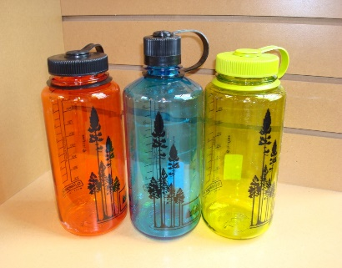
This Photo by Unknown Author is licensed under CC BY-SA

See you all very soon!
l

