Holt Community Primary School

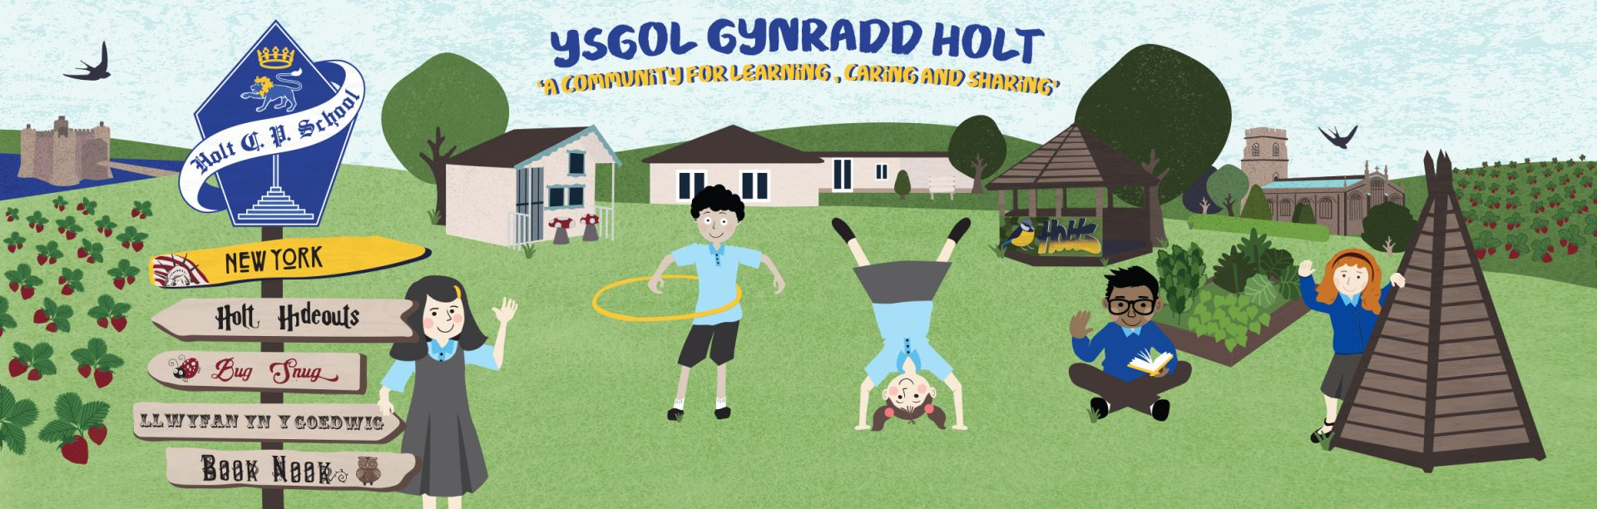

Parent Information Booklet

Guidance and Expectations on re-opening in September

Dear Parents/Guardians,

As you are aware, schools in Wales re-open to pupils from September 3rd 2020. The summer term now ends on Friday July 17th 2020. At Holt Community Primary School, the children will remain within their class groups throughout the duration of the day. They will return to their usual class teacher and teaching assistant. We shall endeavour to ensure that our staff, pupil and parents are prepared – mentally, emotionally and practically for what lies ahead at the beginning of the new school year. We have created this booklet for yourselves to help eliminate any worries and questions you may have. It is statutory for your child to return to school at this time.

I cannot thank you enough for your continued patience and understanding at this time and would like to make you aware that the content of this booklet may be subject to change depending on a number of factors but with the common goal of keeping everyone safe.

Should you have any further queries or concerns then please do get in contact with the school.

Kind regards,

Mrs Melanie Sturt
Headteacher

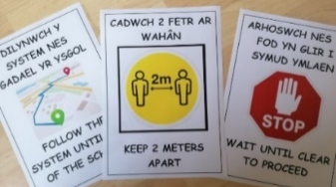
Access to School and Site:

- Learners and parents / carers should attend the school on foot or by using personal mode of transport
- Physical distancing must be observed in the car park / drop off points with adequate space between other people / vehicles.
- Gates for entry will be clearly identified and all others locked.
- Staff will be on gate to guide parents and pupils.
- Signage is in place to help remind parents and pupils of school expectations. Markers will be placed on floor to denote 2m distance.
- Staggered drop off and pick up times will be encouraged.
- Parents to drop off child/ren at the rear gate in the morning. At home time we will expect parents to socially distance on the school yard, and await for their child to be sent to them.
- The carpark is clearly marked with drop off point. Please leave your child with a member of staff.
- Designated route for all pupils to follow – once pupils on site, they are to go straight to wash their hands and then go to their classes, where doors remain open until all group members have arrived.

Displaying of Symptoms in School

- Any employees, learners or parents / carers who are feeling unwell / displaying Covid-19 symptoms must not attend / visit school.
- If anyone becomes unwell when in school, they must leave school as soon as is practical and follow self-isolation guidelines.
- School will report any suspected incidence of Covid-19 symptoms to LA and Public Health Wales.
- Those showing symptoms will be kept separate until they can be collected and taken home. This will be in a separate room, supervised at a distance of two metres. Our isolation room is the current staff room.
- Anyone displaying symptoms should stay at home for seven days.
- Anyone who lives with someone displaying symptoms but remains well should stay at home for 14 days from the day the first person became ill.
- No learner with symptoms should be sent to school at all.
- For the vast majority of learners, Covid-19 is a mild illness. Learners who have been classed as shielding due to pre-existing medical conditions have been advised to undertake specific ‘shielding’ measures. These learners have serious underlying health conditions which put them at very high risk of severe illness from Covid-19 and are advised to rigorously follow shielding measures in order to keep themselves safe. We do not expect these learners to attend schools or settings at this time, and they should continue to be supported at home as much as possible.
- Once someone suspected, confirmed or with symptoms has been identified, all areas where this person has been must be identified and kept clear. A deep clean of the area will be arranged.

First Aid
- There is a First Aid point in every classroom.
- If attending to any wounds, etc school staff will use Personal Protective Equipment (PPE) at all times. A masks, gloves and aprons are available within every classroom.
- Parent / carer need to give permission for learner to attend a doctors surgery or hospital during pandemic.
- If in any doubt (or if not able to contact parent / carer) contact NHS Direct / Emergency Services for advice.
- The usual procedure, in line with school policy and risk assessment, will be followed if a learner was seriously injured or someone with a medical condition needed to be admitted to hospital.
- SLT are willing to go to hospital if parent / carer cannot collect the learner and have given consent.
- Any children that have had a toileting accident are dealt with as per school policy with increased PPE and greater independence encouraged.

Children Arriving For School

- Parents will follow designated route in car park and all children will be dropped off, at staggered times, at the rear gate. This eliminates any unnecessary additional footfall on the school premises and play areas.
- No parents will be allowed on school premises.
- Social distancing rules to be followed once on school premises - from the gates onwards.
- Designated route for all pupils to follow – once pupils on site, they are to go straight to wash their hands and then go to their classes, where doors remain open until all group members have arrived. All doors (apart from fire, toilet and security doors) to be kept open to minimise contamination.
- If parents wish to speak to staff member they can do so via telephone, email or through our digital learning platform.

Whole School Collective Worship

- No whole school / key stage collective worship or assemblies.
- Collective worship to held in individual classes.

P.E

- All P.E lessons will be held outside at present.

Travel Around The School

- Children shall remain in their classes with the same staff where possible. No child should access anywhere within the building but their own classroom and their designated sink and toilet.
- Social distancing mapped and marked across school using floor markings.
- Posters reminding of social distancing evident for all.
- Timetable for toilet breaks where possible: 1 pupil admitted at one time. An allocated cubicle and sink will be available to each class/group.
- All doors apart from fire, toilet and security doors to be kept open.
- Ensure public areas are as clear and free from restrictions as possible.
- All doors / surfaces to be wiped regularly with anti-bacterial wipes before and after snack, by staff.
- Each child has their own tray, which includes work and any equipment they require. This minimises sharing and cross contamination.

Classrooms
- Learners should sit facing the adults where possible.
- Class will be marked with tape to reinforce social distancing from the adults.
- Members of staff within the group will be available to deal with toileting, disinfecting of equipment and to remind pupils of good personal hygiene throughout the school day
- In the Foundation Phase large equipment e.g. bikes, scooters, cars, to be sanitised after using antibacterial wipes.
- Pupils must wear school uniform, including hats and sunscreen if the weather is hot. Children to apply their own sunscreen as in usual school policy.
- 2 adults available for every class where possible.
- Outdoor learning will be used where possible although distancing from other classes is a must.

Play Times
- There will be staggered break times for all groups.
- Pupils to exit class through patio doors leading directly outside, if possible, to avoid corridors.
- Appropriate level of staff supervision during break times.
- Learners to bring snack with them to eat in class – fruit please.
- All learners to wash hands when they return from break.
- Wet play times: children to remain in class and maintain social distancing from adults as usual. Ipads can be used but must be wiped down afterwards with antibacterial wipes.
- Timetabled break times will be limited to 15 minutes for each class. This limits children to not mixing outside of their groups. Pupils will also be allocated zones during playtimes.

Lunch Times
- Staggered lunchtimes have been introduced to ensure social distancing when accessing toilet and handwashing facilities.
- Learners encouraged to bring in their own packed lunch or order a school lunch, which will be eaten in the classroom.
- Staggered playtime before and after eating to ensure social distancing where possible.
- Pupils to bring in their own snack.
- Children will eat their lunches at their designated desks within their classroom.
- Desks will be cleaned before and after lunchtime
- Pupils will wash their hands before and after eating and dispose of rubbish within the bins provided.
- Staff to supervise their classes outside at all times.
- No sharing of food is be permitted.
- Pupils to bring in their own water bottle for use throughout the day.
- Food is to be served in the classrooms. This minimises the risk of transmission of infection. The Local Authority are providing school dinners.
- Staff should ensure that social distancing is maintained at mealtimes.
- In this case, tables will be removed of clutter, disinfected, and visually clean before providing the meal / snack.

Cleaning Routines
- A Deep clean of whole school will have been completed prior to the school reopening.
- Cleaning staff to ensure that all surfaces are deep cleaned at the end of the day.
- Staff will clean surfaces, door handles and equipment throughout the day
- Contracted cleaners will resume their normal hours on return to school.

Blended Learning
- As school returns to full capacity models will be revised to reflect various options going forward.
- Staff will resume teaching the children from the National Curriculum as well as providing activities that promote their well being, physical and creative development.

Cool Cats
- Before and After school club will re-open from September 3rd 2020.

School Uniform
- Every child is required to wear school uniform.
- Clothes should be washed and not be re-worn the following day.

