Holt Community Primary School

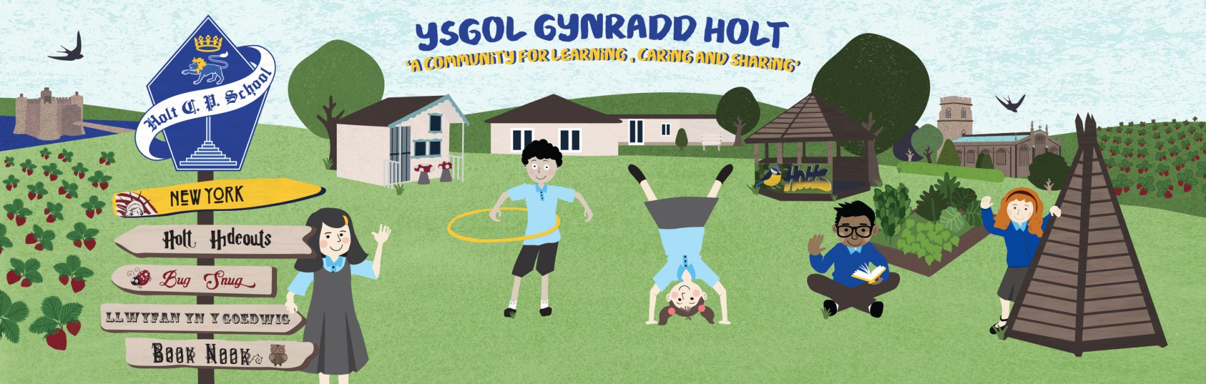

Parent Information Booklet

Guidance and Expectations on re-opening

Dear Parents/Guardians,

As you are aware, schools in Wales re-open to all pupils on June 29th, 2020 with up to a third of their usual capacity, this will include children of key workers and vulnerable learners. The summer term now ends on Friday July 17th 2020. At Holt Community Primary School, we have carefully calculated how many pupils can return from each class and have divided those who are returning into year groups. The children shall remain within those groups throughout the duration of the day. They will return to their usual class teacher and teaching assistant where possible. We fully understand that they will not see all of their friends but we are mindful that this approach is best for all. The purpose of school has also changed as it will now focus on giving the children the opportunity to “Check in, Catch up and Prepare’ for summer and September as we all try and establish what the new normal may look like. We shall endeavour to ensure that our staff, pupil and parents are prepared – mentally, emotionally and practically for what lies ahead. We have created this booklet for yourselves to help eliminate any worries and questions you may have and to assist, as much as possible, in your decision. It is not statutory for your child to return therefore we respect any decision you make regarding what is best for your children at this time.

Please read through it and use as a guide as to what to expect on return. We are also mindful that the children and yourselves would like some clarity as to what the new normal may look like and are therefore in the middle of creating a video showcasing all the changes put in place to make everyone’s return to school the safest possible.

I cannot thank you enough for your patience and understanding at this time and would like to make you aware that the content of this booklet may be subject to change depending on a number of factors but with the common goal of keeping everyone safe.

Should you have any further queries or concerns then please do get in contact with the school.

Kind regards,

Mrs Melanie Sturt
Headteacher
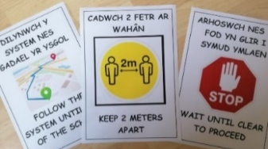
Access to School and Site:

- Learners and parents / carers should attend the school on foot or by using personal mode of transport
- Learners and parents / carers should not car share with other families.
- Physical distancing must be observed in the car park / drop off points with adequate space between other people / vehicles.
- Gates for entry will be clearly identified and all others locked.
- Staff will be on gate to guide parents and pupils.
- Signage is in place to help remind parents and pupils of school expectations. Markers will be placed on floor to denote 2m distance.
- Staggered drop off and pick up times will be introduced.
- Parents to drop off child/ren at the rear gate in the morning. At home time we will expect parents to socially distance on the school yard, and await for their child to be sent to them.
- The carpark is clearly marked with drop off point. Please leave your child with a member of staff.
- One way system in place – signage denotes route
- Designated route for all pupils to follow – once pupils on site, they are to go straight to wash their hands and then go to their classes, where doors remain open until all group members have arrived.

Displaying of Symptoms in School

- Any employees, learners or parents / carers who are feeling unwell / displaying Covid-19 symptoms must not attend / visit school.
- If anyone becomes unwell when in school they must leave school as soon as is practical and follow self-isolation guidelines.
- School will report any suspected incidence of Covid-19 symptoms to LA and Public Health Wales.
- Those showing symptoms will be kept separate until they can be collected and taken home. This will be in a separate room, supervised at a distance of two metres. Our isolation room is the current staff room.
- Anyone displaying symptoms should stay at home for seven days.
- Anyone who lives with someone displaying symptoms but remains well should stay at home for 14 days from the day the first person became ill.
- No learner with symptoms should be sent to school at all.
- For the vast majority of learners, Covid-19 is a mild illness. Learners who have been classed as shielding due to pre-existing medical conditions have been advised to undertake specific ‘shielding’ measures. These learners have serious underlying health conditions which put them at very high risk of severe illness from Covid-19 and are advised to rigorously follow shielding measures in order to keep themselves safe. We do not expect these learners to attend schools or settings at this time, and they should continue to be supported at home as much as possible.
- Once someone suspected, confirmed or with symptoms has been identified, all areas where this person has been must be identified and kept clear. A deep clean of the area will be arranged.

First Aid
- There is a First Aid point in every classroom.
- If attending to any wounds, etc school staff will use Personal Protective Equipment (PPE) at all times. A masks, gloves and aprons are available within every classroom.
- Parent / carer need to give permission for learner to attend a doctors surgery or hospital during pandemic.
- If in any doubt (or if not able to contact parent / carer) contact NHS Direct / Emergency Services for advice.
- The usual procedure, in line with school policy and risk assessment, will be followed if a learner was seriously injured or someone with a medical condition needed to be admitted to hospital.
- SLT are willing to go to hospital if parent / carer cannot collect the learner and have given consent.
- Any children that have had a toileting accident are dealt with as per school policy with increased PPE and greater independence encouraged.

Children Arriving For School

- Parents will follow designated route in car park and all children will be dropped off, at staggered times, at the rear gate. This eliminates any unnecessary additional footfall on the school premises and play areas.
- No parents will be allowed on school premises.
- Social distancing rules to be followed once on school premises - from the gates onwards.
- Designated route for all pupils to follow – once pupils on site, they are to go straight to wash their hands and then go to their classes, where doors remain open until all group members have arrived. All doors (apart from fire, toilet and security doors) to be kept open to minimise contamination.
- If parents wish to speak to staff member they can do so via telephone, email or through our digital learning platform.

Whole School Collective Worship

- No whole school / key stage collective worship or assemblies.
- Collective worship to held in individual classes.

Travel Around The School

- Currently up to a 1/3 of the school population can be admitted at any one time. This is in line than the Welsh Government guidance.
- Children shall remain in their classes or groups with the same staff where possible. Calculations have been made to ensure correct capacity for each class. No child should access anywhere within the building but their classes or groups and their designated sink and toilet.
- Social distancing mapped and marked across school using floor markings.
- Posters reminding of social distancing evident for all.
- Minimise travel around the school by staying in the same classroom throughout the day.
- Timetable for toilet breaks where possible: 1 pupil admitted at one time. An allocated cubicle and sink will be available to each class/group.
- All doors apart from fire, toilet and security doors to be kept open.
- Ensure public areas are as clear and free from restrictions as possible.
- All doors / surfaces to be wiped regularly with anti-bacterial wipes before and after snack, by staff.
- Each child has a learning pack which includes work and any equipment they require. This minimises sharing and cross contamination.

Foundation Phase
- Learners should sit on a designated child-friendly mark on floor. At least two metres away from peers.
- Class will be marked with tape to reinforce social distancing.
- Members of staff within the group will be available to deal with toileting, disinfecting of equipment and to remind pupils of good personal hygiene throughout the school day
- Large equipment e.g. bikes, scooters, cars, to be sanitised after using antibacterial wipes.
- Pupils do not have to wear school uniform. Learners to come to school in clothing suitable for outdoor learning - including hats and sunscreen. Children to apply their own sunscreen as in usual school policy.
- 2 adults available for every group where possible.
- Outdoor learning will be used where possible although distancing from other groups is a must.

Play Times
- There will be staggered break times for all groups.
- Pupils to exit class through patio doors leading directly outside, if possible, to avoid corridors.
- Appropriate level of staff supervision during break times.
- Learners to bring snack with them to eat in class – fruit please.
- All learners to wash hands when they return from break.
- Remind pupils of social distancing at all times in a calm, friendly manner.
- Wet play times: children to remain in class and maintain social distancing as usual. Ipads can be used but must be wiped down afterwards with antibacterial wipes.
- Timetables break times will be limited to 15 minutes for each class/group blocks. This limits children to not mixing outside of their groups. Pupils will also be allocated zones during playtimes.

Lunch Times
- Staggered lunchtimes have been introduced to ensure social distancing when accessing toilet and handwashing facilities.
- Learners encouraged to bring in their own packed lunch and eat in classroom.
- Staggered play time before and after eating to ensure social distancing where possible.
- Pupils to bring in their own snack and lunch.
- Children will eat their lunches at their designated desks within their classroom.
- Desks will be cleaned before and after lunchtime
- Pupils will wash their hands before and after eating and dispose of rubbish within the bins provided.
- Staff to supervise their group outside at all times.
- No sharing of food is be permitted.
- Pupils to bring in their own water bottle for use throughout the day.
- Food is to be served in the classrooms. This minimises the risk of transmission of infection. We are yet to hear whether the Local Authority are providing school dinners.
- Staff should ensure that social distancing is maintained at mealtimes and learners should be sat two metres from each other.
- In this case, tables will be removed of clutter, disinfected, and visually clean before providing the meal / snack.

Cleaning Routines
- A Deep clean of whole school will have been completed prior to the school reopening on June 29th.
- Cleaning staff to ensure that all surfaces are deep cleaned at the end of the day/shift.
- School planned for closure on Wednesdays for deep cleaning between groups attending.
- Staff will clean surfaces, door handles and equipment throughout the day
- Contracted cleaners will resume their normal hours on return to school.

Blended Learning
- As learner numbers increase over time - models will be revised to reflect various options.
- School will be open on Monday, Tuesday, Thursday and Friday and closed on Wednesdays to pupils who are not key workers or vulnerable learners.
- Each child will be allocated a group to attend.
- Children, where possible, will return to their usual class teacher and remain with them for the duration of the day. The usual classroom assistant will be with the group too where possible.
- No staff will go between groups.
- Teachers have every Wednesday for PPA which includes: planning for the next week (both remotely and class based) and time for engaging with learners
- Teachers are not expected to plan differently for distance and class learning. Both groups will be set the same tasks.
- Teachers will remain in contact with distance learners at a time convenient to themselves: Before, after, during school hours.
- Staff will assist the children with their learning as well as provide activities that promote their well being, physical and creative development.
- A ‘Catch Up’ constitutes how the children are getting on, what they may need at home to help them (resources etc) and for them to get the opportunity to see their friends and teachers again.
- ‘Check Ins’ are required whereby staff give children the chance to discuss, share their thoughts and feelings and reflect on how best to move forward with their blended learning.
- ‘Prepare’ is a chance to prepare the children for the new normal. Teaching strategies on solving problems, persevering and how to access help are needed for when they are distance learning and rules and guidelines need to be shared regularly, whilst in school, around how to stay safe and what is expected. These rules are likely to be in force for a long time therefore the children need to be aware of what they are and why they are in place.

Cool Cats
- Before and After school club will not be available at this time.

School Uniform
- No child is required to wear school uniform.
- Clothes should not be re-worn the following day.
- Clothing suitable for outdoor use is encouraged.

